**OPENING FILES**

The below program will print th2 21 lines of a text (Python_Zen) and out of that it will print only 4 bytes per line (4 characters per line).

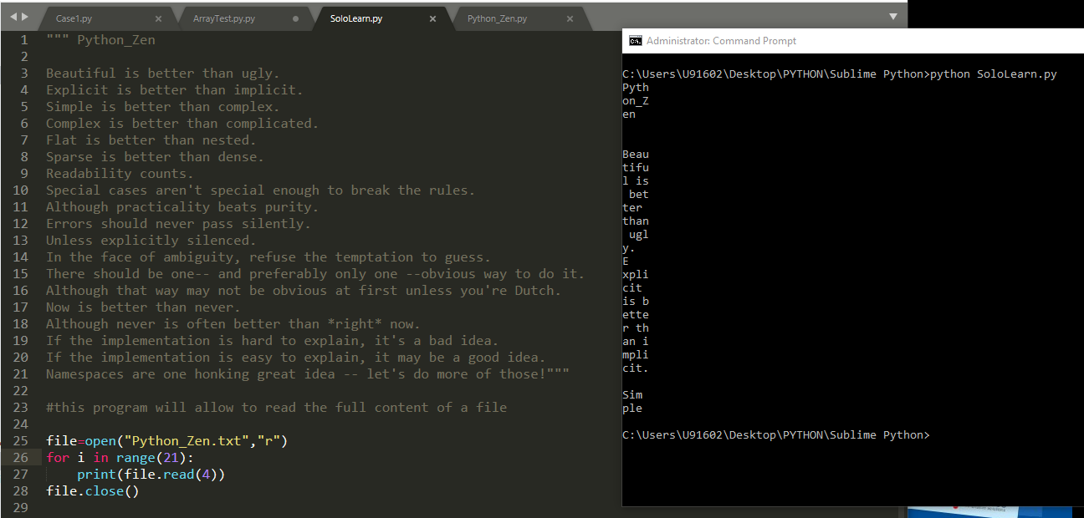

Writing files example:

The instruction will create a new file if it does not exist.

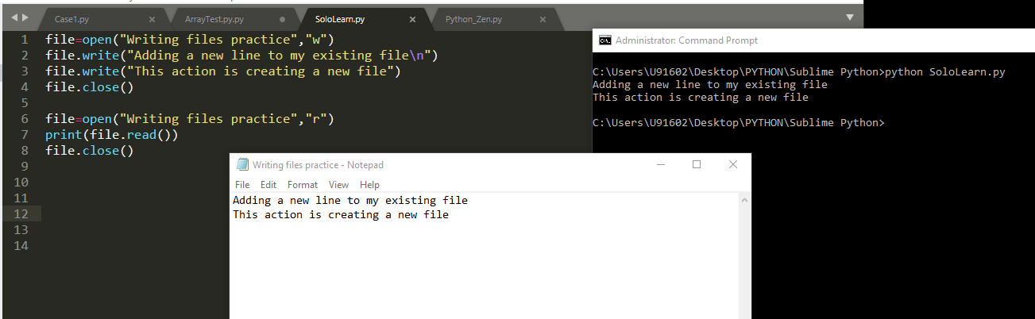

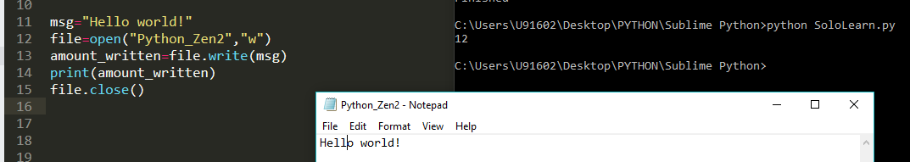

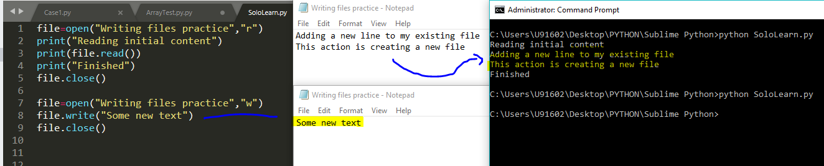

The “None” object

The output on the right bottom shows these two are different objects

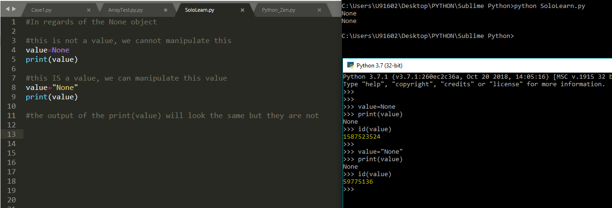

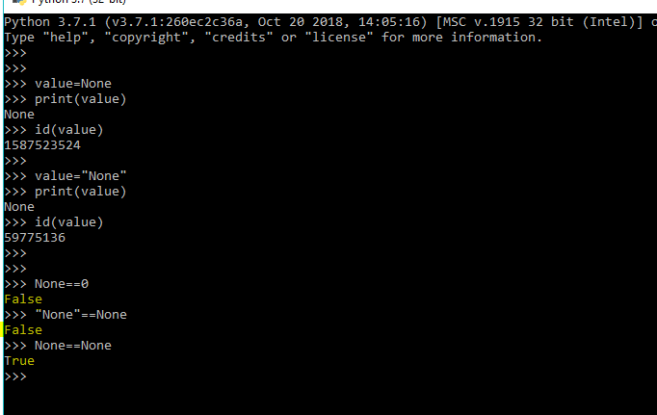

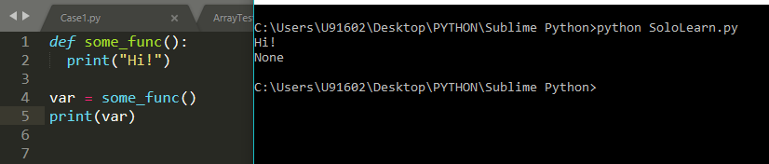

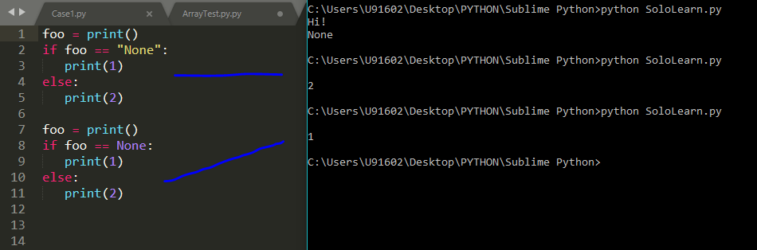

String functions

Examples

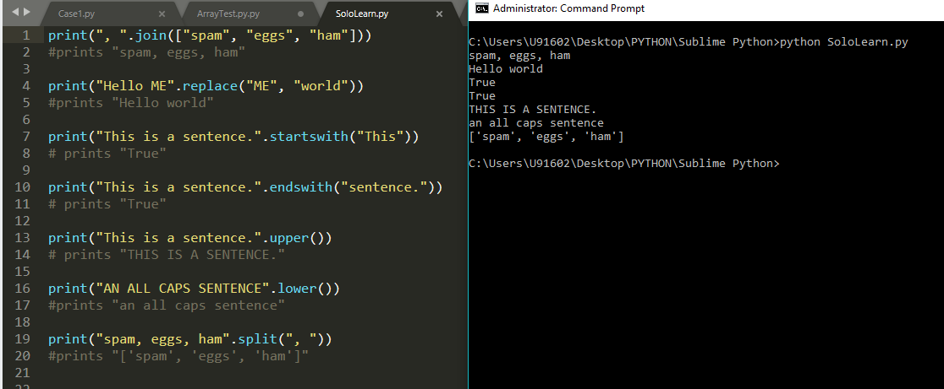

Text Analyzer

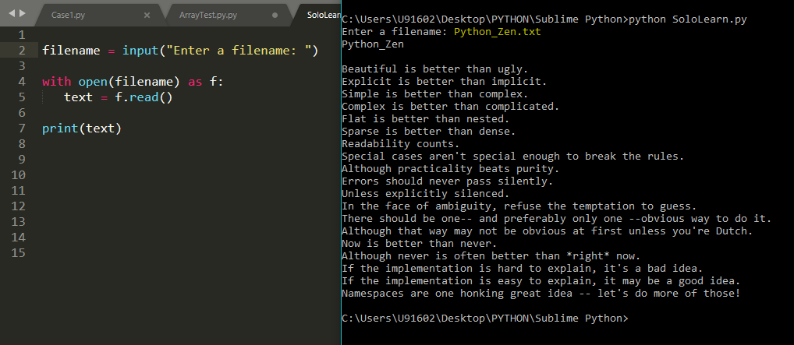

This part of the program shows a function that counts how many times a character occurs in a string.

This function takes as its arguments the text of the file and one character, returning the number of times that character appears in the text. Now we can call it for our file.

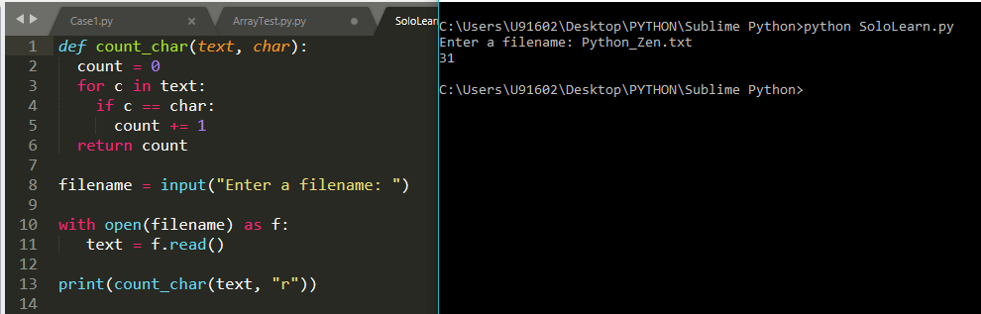

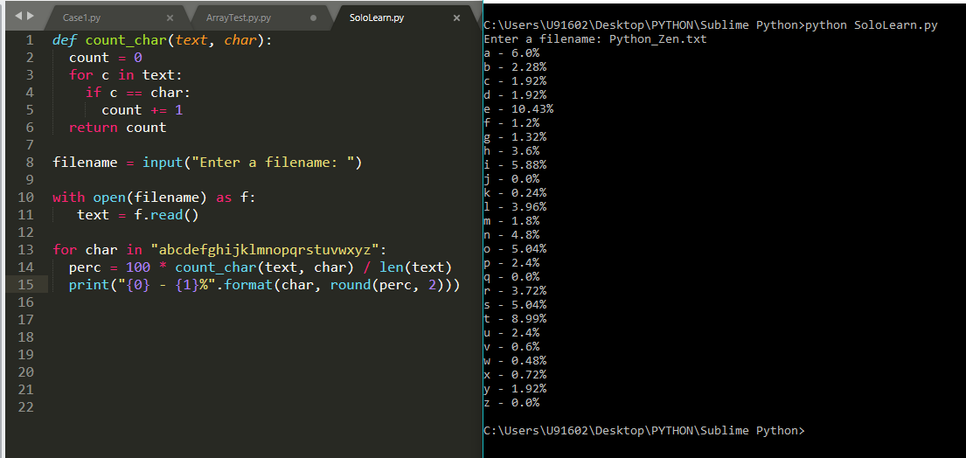

Generators:

Examples

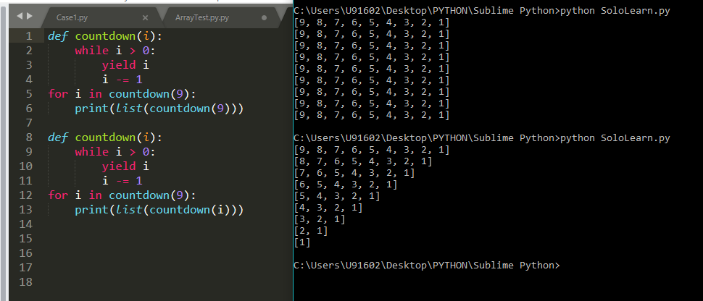

More examples generators:

What is the result of this code?

